*Lab Report -4*

*Motor Sequence Learning*

*PSY310 – Lab in Psychology*

*Nirja Sukhadia*

*AU2120057*

Github link –

**Introduction**

Motor sequence learning is a procedure in which an ordered list or sequence of motor actions is performed with greater accuracy and speed over time. It involves having the ability to perform simple movements as a single sequence through repeated similar actions. Human contingency learning is defined as acquisition of implicit or explicit knowledge of statistical correlations between stimuli and/or response. This is closely related to operant conditioning, as people tend to learn whichever response has the highest probability of acquiring the desired outcome (Schmidt)

Motor sequence learning task here is used to understand human contingency learning, as the task requires the participants to predict the sequence of stimuli and respond accurately. This type of learning helps in processing the stimuli and responding faster, further reducing the reaction time.

**Method**

One participant of 21 years old enrolled in Ahmedabad University was recruited to participate in the task. The experimental setup was designed on PsychoPy software on a 16” laptop. The experiment consisted of a fixation of cross at the beginning to gather the participant’s attention to that particular point on the screen. After the duration of the fixation is passed, four rectangles of the same orientation and size appear at the centre of the screen. A triangle as a probe of size[w,h] = (10,10) was then added with ‘pos, 60’ to specify the location, where ‘pos’ indicated the variable of position. A key response starting at 2 seconds, with correct response being stored in $corr_resp. A loop was added to the trial, with loopType as Sequential, ensuring that the stimulus is appearing in a particular sequence and is repeated for learning to happen. Then a csv conditions file was inserted which specified the position of the probe and its correct response. The four conditions were -50, 150, 50, -150 with correct responses as x, v, c, z respectively.

And finally, a second routine was added, with the only difference as a randomised sequence of the stimulus appearing, with loopType as fullRandom, and the same conditions file was attached as before

**Results**

The mean reaction time for random routine is 0.599480746, and the mean reaction time for sequential routine was calculated to be 0.43748084. The mean reaction time for random routine is higher than the sequential routine. The plot below shows the comparison between the reaction times of the two routines.

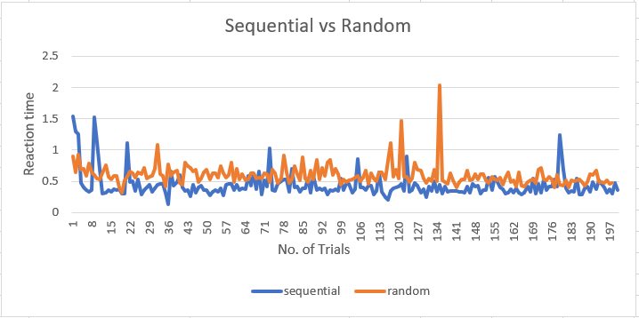

*Figure 1. Change in RTs across the trials*

**Discussion**

We can see that the reaction time decrease in the sequential conditions as the participant could predict the upcoming stimuli as they have learned the sequence of appearance of the triangle after a point. The participant took lesser time to process the stimuli and could response faster, revealing motor learning effect. However, the reaction time in random condition routine does not show a decrease in RTs as the stimuli no longer followed a sequence and the participant had to process the stimuli completely before responding. Thus, the reaction time shoots up when the routine changes from sequential to random. As we know learning effects are due to prior practice. To deal with this issue counterbalancing technique can be used by dividing the participants and changing the order of routines for both the groups. This can help us eliminate order and practice effects, further improving the study.

# Bibliography

Schmidt, J. R. (n.d.). Human Contingency learning. *Spinger link*, 1455-1456.